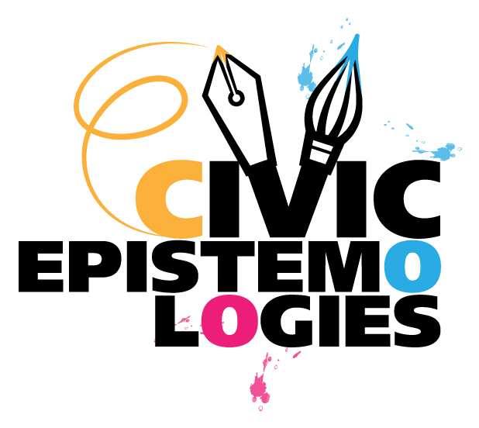 | Memorandum of Understanding  between  Civic Epistemologies and XXXXXX | PROJECT LOGO

A Memorandum of Understanding (MoU) is hereby concluded between:
Civic Epistemologies Consortium, represented by the Technical Coordinator Promoter Srl
and
XXXXXX Consortium represented by XXXXXX
Each a “Party” and together “The Parties”
Provided that
CIVIC EPISTEMOLOGIES is a Coordination and support action project funded by the European Union’s Seventh Framework Programme for research, technological development and demonstration, under the Grant Agreement 632694, and its aim is to develop and validate a Roadmap for the use of e-Infrastructures to support the participation of European citizens in research on cultural heritage and digital humanities.
2) The CIVIC EPISTEMOLOGIES project is coordinated by the Italian Ministry of Economic Development, represented by Dr. Mauro Fazio and Technical coordinator is partner Promoter Srl, represented by Dr. Antonella Fresa who is responsible also for the Communication and Networking;
3) The CIVIC EPISTEMOLOGIES project has the following goals:
- Analyze the needs of researchers, citizens, cultural institutions and creative enterprises;
- Develop a new Roadmap based on key findings;
- Validate the Roadmap through one Pilot in Ireland and two case studies in the UK;
- Encourage Research institutions to establish clear protocols for citizen engagement and shared research goals where achievable;
- Ensure widespread impact of the project findings with a strong communication and dissemination plan;
- Establish a durable network of common interest to connect cultural institutions, research bodies, creative industries, e-infrastructures and citizen associations;

4) These goals will be accomplished also through the work of the CIVIC EPISTEMOLOGIES Network of Common Interest constituted by:
- Experts from cultural institutions;
- Experts from ICT and E-infrastructure providers, policy makers and research centers;
- Experts from Public Bodies and Universities;
- Experts from SMEs and creative enterprises;
- Experts from the digital humanities and social sciences centres;

The Parties receive funding support from the European Commission and recognise the complementarities amongst objectives and activities of their respective projects.
Having assessed the potential benefits of a coordinated collaboration approach, The Parties have agreed to co-operate under the conditions established in the following articles.
In consideration of the mutual rights and obligations hereto, the Parties hereby agree:
Article 1. Subject Matter
The purpose of this MoU is to facilitate the collaboration between The Parties in order to improve the overall results and expected impacts of such actions.
Activities which will be undertaken in common by The Parties are listed in Annex 1 to this MoU.
The Parties may from time to time wish to add other activities to the MoU. In such case the new activities to be added will be agreed in writing by the respective Contact Persons and be defined by an amendment of this MoU, simply adding a new Annex 1.
Article 2. Communication
The Parties will appoint at least one Principal Point of Contact (Contact Person) to act as the technical channels of communication as is necessary for the promotion of effective cooperation between them. The Contact People will maintain regular contact to discuss any matter related to the cooperation described in this MoU or to be integrated in it.
Article 3. Contributions
Each Party shall bear its own costs resulting from their participation in these collaboration activities, unless other agreement is reached for a particular task, taking into account the Financial Regulations governing the EU Projects.
Each Party will maintain the full responsibility for its own activities, including the fulfilment of its obligations under its contract with the European Commission and provides no warranty, express or implied, in respect of its contribution to any activity agreed by The Parties under this MoU, including but not limited to those of fitness for a particular purpose and the infringement of third-party proprietary rights.
Any proprietary rights, relating to the results of activities undertaken jointly by The Parties under this MoU, shall be jointly held, and Each Party herewith grants the other a free, irrevocable and perpetual license to use such rights.
Article 4. Confidentiality
The Parties agree not to disclose privacy protected information of any of the concerned projects to any third party, unless expressly agreed by the concerned Parties in written. This article is agreed by the Parties to be legally binding.
Article 5. Legal Nature
The Parties expressly affirm that this Cooperation Agreement is not a legally binding contract, save for Article 4, but it is intended to confirm the basic settings agreed upon and the goodwill of the Parties to materialise a fruitful collaboration.
Article 6. Duration
This MoU enters into force from the date of its signature. It will terminate when either of The Parties´ projects is ended or when a Party gives notice of termination to the other, in which case a minimum notice of two months will be given in written.
In the case that The Parties will continue their activities beyond the completion of the Grant Agreements with the European Commission, this MoU can be renewed on the basis of a mutual decision.

Signatures
For CIVIC EPISTEMOLOGIES
SIGNED BY: Antonella Fresa
AFFILIATION: Promoter Srl, Via Boccioni, 2 - 56037 Peccioli (Pisa), Italy

TITLE: Technical Coordinator
Signature ……………………………………………………………
Date: ……………………………………………………………
For XXXXXX
SIGNED BY: XXXXXX
AFFILIATION: XXXXXX

TITLE: XXXXXX
Signature ……………………………………………………………
Date: ……………………………………………………………

 | Annex 1 - Memorandum of Understanding  between  Civic Epistemologies and XXXXXX | PROJECT LOGO
Coordinated Activities
- Promotion and presentation of the results of the concerned projects in the respective websites, events and publications
- Organization of joint events, such as workshops (general/specifics topics), networking sessions, webinars, training courses, focus groups, etc.
- Organization of joint participation (with joint presentations and/or demonstrations) at specialised events and conferences organised by other institutions and projects
- Implementation of “clustering” activities, generation of internal workshops and symposia sessions for stimulating dissemination and collaboration among concerned projects´ participants
- Publications of articles on the work and results of the concerned projects in scientific journals and in sector specific online publications, such as Digital Meets Culture (www.digitalmeetsculture.net)
- Posting joint news on third party websites, newsletters and social media channels
- Circulation of joint announcements/results via relevant mailing lists
- Pursuing the formulation of suggestions/recommendations/advice to relevant standardization bodies and special interest workgroups
- ………………………………………………
Contact People
CIVIC ESPISTEMOLOGIES contact people for the execution of this MoU will be:
- Antonella Fresa, Technical Coordinator – Promoter Srl – Via Boccioni, 2 - 56037 Peccioli (Pisa), Italy – +39.0587.466881 – fresa@promoter.it
XXXXXX contact people for the execution of this MoU will be:
- FirstName LastName – Affiliation – Address – Phone – email
- FirstName LastName – Affiliation – Address – Phone – email

